UNIVERSITY INSTITUTE OF TECHNOLOGY
RAJIV GANDHI PROUDYOGIKI VISHWAVIDYALAYA,
AIRPORT BYPASS ROAD, GANDHI NAGAR
BHOPAL – 462033


MAJOR PROJECT ON

“FACE RECOGNITION AND PASSWORD BASED DOOR LOCK SECURITY SYSTEM”
A THESIS SUBMITTED IN THE PARTIAL FULFILLMENT OF REQUIREMENT FOR THE AWARD OF
BACHELOR OF TECHNOLOGY

DEPARTMENT OF
ELECTRONICS AND COMMUNICATION ENGEINEERING
BATCH 2023-26

UNDER THE SUPERVISION OF:- SUBMITTED BY:-

PROF.CHATURBHUJ AHIRWAR ANJALI SINGH (0101EC233D02)
DEEPAK PRAJAPATI (0101EC223D13)
RUCHITA MARKO (0101EC233D06)
AASHNI MARSKOLE (0101EC221005)

UNIVERSITY INSTITUTE OF TECHNOLOGY
RAJIV GANDHI PROUDYOGIKI VISHWAVIDYALAYA

Department of Electronics & communication Engineering

Academic year 2026
We hereby declare that the work, which is being presented in the report, entitled “Face Recognition and Password Based Door Lock Security System”, in the partial fulfillment of the requirements for the award of the degree of Bachelor of Technology in Electronics & Communication Engineering, is an authentic record of our own work carried out under the guidance of Prof. Chaturbhuj Ahirwar.

We have also cited the reference about the texts/ figures/ tables from where they have been taken. The matter presented in this report anf the project made has not been submitted elsewhere for the award of any degree or diploma from any other Institution.

DATE:-

S.No | Name of candidates | Signature
1. | Anjali Singh
2. | Deepak Prajapat
3. | Ruchita Marko
4. | Aashni Marskole

This is to certify that the above statement made by the candidate is correct to the
best of my knowledge.

Supervisor of
Prof Chaturbhuj Ahirwar
Seen,
Dr. Anubhuti Khare Prof. Sudhir Singh Bhadauria
(Head of Department) (Director)

ABSTRACT :
In the modern digital era, ensuring the security of systems and data has become a critical concern. Traditional authentication methods, particularly password-based systems, are widely used due to their simplicity and ease of implementation. However, these systems suffer from several vulnerabilities such as weak password selection, password sharing, brute-force attacks, and phishing, which can lead to unauthorized access and data breaches. Therefore, relying solely on passwords is no longer sufficient to ensure robust security.
To address these challenges, this project proposes a dual-layer authentication system that integrates password-based authentication with biometric face recognition technology. Face recognition is a widely accepted biometric technique that identifies individuals based on unique facial features, making it difficult to replicate or forge.
The proposed system operates in two sequential stages. In the first stage, the user is required to enter valid login credentials, including a username and password. The system verifies these credentials against stored data in the database. Upon successful verification, the system proceeds to the second stage, where it activates a camera to capture the user's live facial image. Using advanced image processing techniques and machine learning algorithms, the system detects and encodes facial features, which are then compared with pre-stored facial data of the authorized user.
If the captured facial data matches the stored data within an acceptable threshold, the system grants access; otherwise, access is denied. This two-step verification significantly enhances the overall security of the system by ensuring that even if a password is compromised, unauthorized users cannot gain access without passing the biometric verification.
The system is implemented using technologies such as Python, OpenCV, and face recognition libraries, along with a user-friendly interface developed using Streamlit. The database stores user credentials and facial data securely. The system is designed to be efficient, reliable, and easy to use, making it suitable for real-world applications.
Experimental results indicate that the system achieves high accuracy in face recognition under proper lighting conditions and provides faster authentication compared to traditional methods. However, certain limitations such as dependency on lighting conditions and camera quality may affect performance.
Overall, this project demonstrates that combining password-based authentication with face recognition provides a more secure and robust solution for modern security systems. It can be effectively applied in various domains such as smart access control, attendance management, banking security, and surveillance systems.
यह system traditional security methods की तुलना में अधिक सुरक्षित है और unauthorized access को काफी हद तक रोकता है, जिससे यह real-world applications के लिए एक effective solution बनता है।

INTRODUCTION :

In today’s rapidly evolving digital world, security has become one of the most critical concerns for individuals as well as organizations. With the increasing use of online platforms, smart devices, and automated systems, the need for reliable and robust authentication mechanisms has grown significantly. Authentication is the process of verifying the identity of a user before granting access to a system, and it plays a vital role in protecting sensitive data and resources from unauthorized access.
Traditionally, authentication systems have relied heavily on password-based mechanisms. In such systems, users are required to enter a username and password to gain access. Although this method is simple and widely adopted, it suffers from several major drawbacks. Users often create weak passwords that are easy to guess, reuse the same password across multiple platforms, or share their passwords with others. These practices make password-based systems highly vulnerable to various types of attacks such as brute-force attacks, dictionary attacks, phishing, and credential theft.
To overcome the limitations of traditional authentication methods, biometric technologies have been introduced. Biometric authentication uses unique physical or behavioral characteristics of an individual, such as fingerprints, iris patterns, voice, or facial features, to verify identity. Among these, face recognition has gained significant popularity due to its non-intrusive nature, ease of use, and increasing accuracy with advancements in computer vision and machine learning.
Face recognition technology works by capturing an image of a person’s face, extracting distinctive features, and comparing them with stored data to identify or verify the individual. It has been widely used in various applications such as smartphone unlocking, surveillance systems, attendance tracking, and security checkpoints.
However, biometric systems also have certain limitations. Factors such as lighting conditions, camera quality, facial expressions, and environmental variations can affect the accuracy of face recognition systems. In some cases, relying solely on biometric authentication may not provide complete security.
Therefore, a more effective approach is to combine multiple authentication methods to create a multi-layered security system. This project focuses on developing a dual-layer authentication system that integrates password-based authentication with face recognition technology. By combining these two methods, the system enhances security and reduces the chances of unauthorized access.
In the proposed system, the authentication process is divided into two stages. In the first stage, the user is required to enter valid login credentials (username and password). The system verifies these credentials using a database. If the credentials are correct, the system proceeds to the second stage, where it activates a camera to perform face recognition. The captured facial image is processed and compared with the stored facial data of the authorized user. Only when both stages are successfully completed, access is granted to the system.
This dual authentication mechanism ensures that even if a password is compromised, an unauthorized user cannot gain access without passing the face recognition verification. Thus, it significantly improves the overall security of the system.
The implementation of this project is carried out using modern technologies such as Python programming language, OpenCV for image processing, and face recognition libraries for biometric verification. A user-friendly interface is developed using Streamlit, which allows easy interaction with the system. The database stores user credentials and facial data required for authentication.
This project has wide applications in real-world scenarios where security is a top priority. It can be used in smart door locking systems, secure login platforms, attendance management systems, banking applications, and parking systems. The system is designed to be efficient, reliable, and scalable, making it suitable for both small-scale and large-scale applications.
In conclusion, the integration of password-based authentication with face recognition technology provides a more secure and robust solution compared to traditional single-layer authentication systems. This project aims to demonstrate the effectiveness of such a hybrid approach in enhancing system security and ensuring safe access control.
PROBLEM STATEMENT :

• Traditional authentication systems mainly rely on passwords, which are not fully secure.
• Users often create weak passwords or reuse the same password across multiple platforms.
• Passwords can be easily compromised through attacks such as:
- Brute-force attacks
- Phishing
- Keylogging
• Password-based systems do not verify the actual identity of the user.
• Unauthorized users can gain access if they know the correct password.
• Biometric systems like face recognition improve security but have limitations such as:
- Dependence on lighting conditions
- Camera quality issues
- Possibility of false detection
• Single-layer authentication (only password or only biometric) is not sufficient for high-security systems.
• There is a need for a more secure and reliable authentication system.
• A dual-layer system combining password and face recognition can reduce security risks.
• The main problem is to design a system that ensures:
- Accurate user verification
- Prevention of unauthorized access
- High reliability and efficiency

OBJECTIVES :
The primary objective of this project is to design and develop a secure and reliable authentication system that enhances the overall security of user access by combining password-based authentication with face recognition technology. In today’s digital environment, where security threats are continuously increasing, it is essential to implement advanced authentication mechanisms that can effectively prevent unauthorized access.
One of the key objectives of this project is to integrate two different authentication methods — traditional password verification and biometric face recognition — into a single system. By doing so, the system provides a dual-layer security mechanism, ensuring that access is granted only when both authentication steps are successfully completed. This significantly reduces the risk associated with single-layer authentication systems.
Another important objective is to improve the accuracy and reliability of user verification. Password-based systems alone cannot confirm the actual identity of the user, while face recognition provides identity verification using unique facial features. Combining these two approaches helps in achieving a more accurate and secure authentication process.
The project also aims to design a user-friendly interface that allows users to interact with the system easily. The system should be simple to use, efficient, and capable of performing authentication in real time without causing delays. For this purpose, a web-based interface is developed using modern tools to ensure smooth user experience.
Additionally, the project focuses on minimizing security risks such as password theft, unauthorized access, and identity fraud. By introducing biometric verification, even if a password is compromised, the system prevents access unless the user’s face is recognized successfully.
Another objective is to implement the system using widely used and efficient technologies such as Python, OpenCV, and face recognition libraries. These technologies enable accurate detection and recognition of faces, making the system reliable and practical for real-world applications.
The project also aims to store user data securely, including login credentials and facial data, in a database. Proper data management ensures that the system remains organized and scalable for multiple users.
Furthermore, the system is designed to be tested under different conditions to evaluate its performance, accuracy, and reliability. This helps in identifying limitations and improving the system for better results.
In summary, the overall objective of this project is to develop a robust, efficient, and secure authentication system that combines the strengths of both password-based and biometric authentication methods to provide enhanced security and improved user verification.

LITERATURE REVIEW :

In recent years, authentication systems have become a major area of research due to the increasing need for secure access control in digital systems. Various methods of authentication have been developed, including knowledge-based, possession-based, and biometric-based systems. Each of these approaches has its own advantages and limitations.
Initially, most systems relied on password-based authentication, which is a knowledge-based method. In this approach, users are required to remember and enter a secret password to gain access. According to several studies, password-based systems are simple and cost-effective; however, they are highly vulnerable to security threats. Users often choose weak passwords or reuse them across multiple platforms, making them easy targets for attacks such as brute-force attacks, dictionary attacks, and phishing. Research has shown that a significant number of data breaches occur due to compromised passwords, highlighting the limitations of this method.
To overcome the weaknesses of password-based systems, researchers introduced biometric authentication systems, which use unique physical or behavioral characteristics of individuals for identification. Common biometric methods include fingerprint recognition, iris recognition, voice recognition, and face recognition. Among these, face recognition has gained considerable attention due to its non-intrusive nature and ease of use.
Face recognition systems work by capturing an image of a person’s face, extracting distinctive features, and comparing them with stored templates in a database. With advancements in computer vision and machine learning, face recognition technology has achieved significant improvements in terms of accuracy and speed. Studies indicate that modern face recognition systems can achieve high accuracy under controlled conditions.
However, despite these advancements, face recognition systems also have certain limitations. Their performance can be affected by external factors such as lighting conditions, camera quality, facial expressions, occlusions (e.g., masks, glasses), and changes in appearance over time. Additionally, some studies have reported issues related to false acceptance and false rejection rates, which can impact system reliability.
Due to the limitations of both password-based and biometric systems, researchers have explored the concept of multi-factor authentication (MFA). Multi-factor authentication combines two or more authentication methods to provide enhanced security. These methods typically include something the user knows (password), something the user has (security token), and something the user is (biometric data).
Several research papers suggest that combining password-based authentication with biometric verification significantly improves system security. For example, hybrid systems that integrate passwords with fingerprint or face recognition have shown better resistance against unauthorized access. These systems ensure that even if one layer of security is compromised, the second layer provides additional protection.
Recent studies have focused specifically on face recognition combined with password authentication. These systems follow a two-step verification process, where the user first enters login credentials and then undergoes biometric verification. This approach reduces the risk of identity theft and enhances trust in the system.
In addition to authentication techniques, researchers have also worked on improving the performance of face recognition algorithms. Techniques such as Haar Cascade Classifiers, Local Binary Patterns Histogram (LBPH), and deep learning-based models have been widely used for face detection and recognition. OpenCV, an open-source computer vision library, provides efficient tools for implementing these techniques in real-world applications.
Furthermore, the development of user-friendly interfaces has also been an important aspect of recent research. Modern systems use web-based frameworks such as Streamlit to create interactive and easy-to-use applications. This improves user experience and makes the system more accessible.
In conclusion, the literature suggests that while individual authentication methods have their own strengths and weaknesses, combining multiple methods provides a more secure and reliable solution. The integration of password-based authentication with face recognition is an effective approach to address the limitations of traditional systems. This project is based on these research findings and aims to develop a hybrid authentication system that offers improved security, accuracy, and usability.

METHODOLOGY :

The methodology of this project describes the complete working process of the proposed system, including how the system performs authentication using both password verification and face recognition. The system is designed in a structured and sequential manner so that each step ensures proper validation of the user before granting access.
The overall working of the system is divided into two main phases:
(1) Password Authentication Phase and
(2) Face Recognition Phase
Both phases must be successfully completed for access to be granted.

Step 1: User Input (Login Stage)
The process begins when the user interacts with the system through a user-friendly interface developed using Streamlit. The user is required to enter their username and password in the login form.
This step acts as the first layer of security, where only registered users with valid credentials can proceed further.

Step 2: Password Verification
Once the user enters the login details, the system verifies the credentials by comparing them with the stored data in the database.
- If the username and password match the stored records, the system proceeds to the next step.
- If the credentials are incorrect, access is immediately denied, and the user is prompted to try again.
This step ensures that only authorized users can move to the next level of authentication.

Step 3: Camera Activation
After successful password verification, the system activates the webcam or camera device to initiate the face recognition process.
A message is displayed on the screen instructing the user to position their face properly in front of the camera. This improves the accuracy of face detection and recognition.

Step 4: Face Detection
In this step, the system captures real-time video frames using the camera. Each frame is processed to detect the presence of a human face.
Face detection is performed using computer vision techniques provided by OpenCV. The system identifies the region of the image that contains the face and isolates it for further processing.
This step is important because accurate detection is necessary before performing recognition.

Step 5: Face Encoding
Once the face is detected, the system extracts unique facial features and converts them into a numerical format known as a face encoding.
This encoding represents important characteristics of the face, such as the distance between eyes, shape of facial structure, and other distinguishing features.
The same process is applied to the stored images of authorized users.

Step 6: Face Matching (Recognition Stage)
In this stage, the system compares the captured face encoding with the stored encoding of the registered user.
- If the similarity between the two encodings is within an acceptable threshold, the face is considered a match.
- If the similarity is low, the system concludes that the face does not belong to the authorized user.
This comparison ensures accurate identity verification.

Step 7: Access Decision
Based on the results of both authentication phases:
- ✅ If password verification + face recognition दोनों successful होते हैं, access is granted.
- ❌ If any one of the steps fails, access is denied.
This dual-layer mechanism ensures a high level of security.

Step 8: System Response
The system provides feedback to the user:
- On success: “Access Granted” message is displayed.
- On failure: “Access Denied” message is shown.
This improves user experience and clarity.

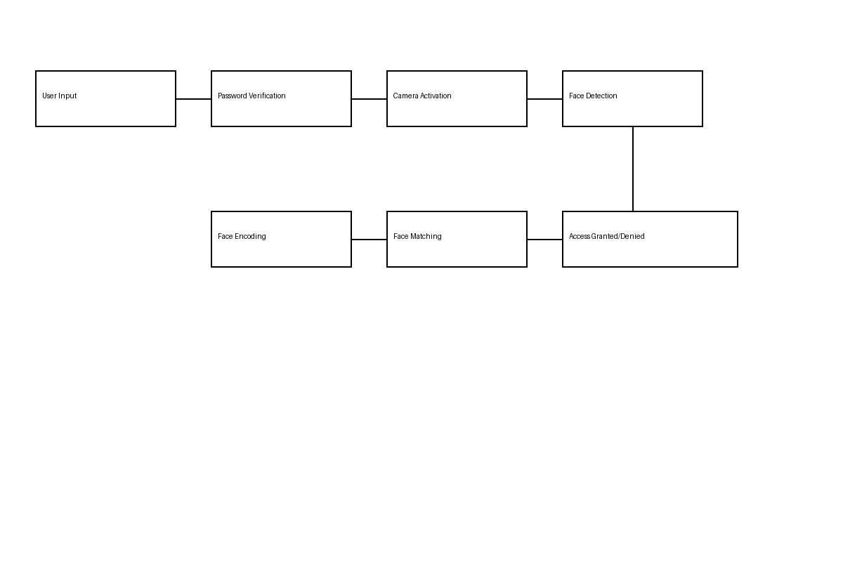
“Figure: Methodology of Face Recognition Based Authentication System”
SYSTEM ARCHITECTURE :
The system architecture represents the overall structure and working of the proposed authentication system. It shows how different components interact with each other to perform secure user authentication using password verification and face recognition.
The system is designed in a modular way, where each component performs a specific function. These components work together to ensure that only authorized users are granted access.

MAIN COMPONENTS OF THE SYSTEM

1. User Interface (UI)
The User Interface is the front-end part of the system through which the user interacts with the application. It is developed using Streamlit to provide a simple and user-friendly experience.
- Allows user to enter username and password
- Displays messages (success/failure)
- Guides user during face verification
Its entry point of System

2. Authentication Module
This module handles the verification of user credentials.
- Receives username and password from UI
- Compares with stored data in database
- Validates user identity (first layer security)
Agar password galat hai → system yahi stop ho jata hai

3. Database Module
The database stores all the required user information.
- Username
- Password
- User face image / encoding
This module is responsible for managing and retrieving data securely.
Example: Firebase / MySQL / Local storage

4. Face Recognition Module
This is the core module of the system.
It performs the following tasks:
- Captures image using camera
- Detects face using OpenCV
- Converts face into encoding
- Matches with stored face data
Ye second layer security provide karta hai

5. Camera / Input Device
The camera is used to capture real-time images of the user.
- Activates after password verification
- Provides input for face recognition

6. Decision Module
This module takes the final decision based on results:
- If both password and face match → Access Granted
- Otherwise → Access Denied

1. SOFTWARE LAYER
This layer handles user authentication and face recognition.

Components:
- User Interface (Streamlit) → User login
- Authentication Module → Password verification
- Face Recognition Module → Face detection & matching
- Database → Stores user data
Ye part decision banata hai: access milega ya nahi

2. HARDWARE LAYER
This layer executes physical actions based on authentication result using microcontroller.

Components:

✅ Arduino Nano
- Acts as the main controller
- Receives signal from Python system via Serial Communication (USB)
- Controls all hardware devices

✅ LED (Red & Green)
- Green LED → Access Granted
- Red LED → Access Denied
Visual indication ke liye use hota hai

✅ Buzzer
- Access granted → Short beep
- Access denied → Continuous beep
Alert system ke liye use hota hai

✅ Servo Motor
- Access granted → Gate/Door open (rotate 90°)
- Access denied → No movement
Real-world application (smart lock / parking gate)

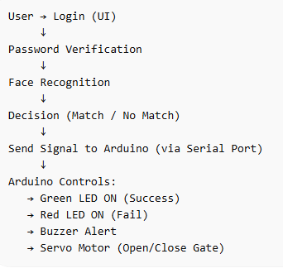

ARCHITECHTURAL DIAGRAM :

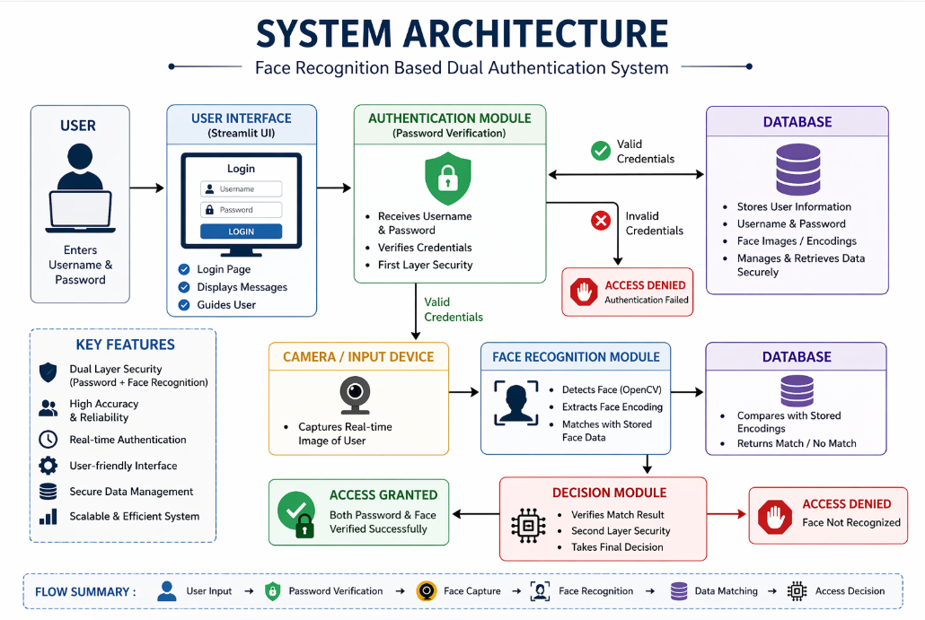

1. COMPLETE WORKING
System flow:
- Face + Password verified (Python side)
- Python → Arduino ko signal bhejta hai
- Arduino → LED + Buzzer + Servo control karta hai

2. PYTHON → ARDUINO SERIAL CODE
serial_control.py
import serial
import time
# Arduino port (check in Device Manager)
arduino = serial.Serial('COM3', 9600)
time.sleep(2)
def access_granted():
arduino.write(b'1') # send signal 1
def access_denied():
arduino.write(b'0') # send signal 0
👉 Use in your app.py:
from serial_control import access_granted, access_denied
if result:
access_granted()
else:
access_denied()

3. ARDUINO CODE (FULL WORKING)
#include <Servo.h>
Servo myServo;
int greenLED = 2;
int redLED = 3;
int buzzer = 4;
int servoPin = 5;
void setup() {
Serial.begin(9600);
pinMode(greenLED, OUTPUT);
pinMode(redLED, OUTPUT);
pinMode(buzzer, OUTPUT);
myServo.attach(servoPin);
myServo.write(0); // closed position
}
void loop() {
if (Serial.available() > 0) {
char data = Serial.read();
if (data == '1') {
// ACCESS GRANTED
digitalWrite(greenLED, HIGH);
digitalWrite(redLED, LOW);
tone(buzzer, 1000);
delay(300);
noTone(buzzer);
myServo.write(90); // open gate
delay(3000);
myServo.write(0); // close
digitalWrite(greenLED, LOW);
}
else if (data == '0') {
// ACCESS DENIED
digitalWrite(redLED, HIGH);
for (int i = 0; i < 3; i++) {
tone(buzzer, 500);
delay(300);
noTone(buzzer);
delay(200);
}
digitalWrite(redLED, LOW);
}
}
}

4. WIRING CONNECTIONS

LED
- Green LED → Pin 2
- Red LED → Pin 3
- GND → Arduino GND

Buzzer
  - → Pin 4
- – → GND

Servo Motor
- Red → 5V
- Brown → GND
- Yellow → Pin 5

Arduino Connection
- Arduino Nano → USB → Laptop

TECHNOLOGIES USED :
The development of the proposed system is carried out using a combination of software and hardware technologies to ensure efficient performance, real-time processing, and secure authentication. The selected technologies are reliable, widely used, and suitable for implementing both biometric and embedded system functionalities.

Software Technologies

Python
Python is used as the primary programming language for the development of the system. It provides a simple and efficient environment for implementing the authentication logic, integrating different modules, and handling real-time operations. Its extensive library support makes it highly suitable for computer vision and hardware communication tasks.

OpenCV (Open Source Computer Vision Library)
OpenCV is utilized for image processing and face detection. It enables the system to capture real-time video input from the camera and detect facial regions within each frame. The library offers optimized functions that ensure fast and accurate detection, which is essential for real-time applications.

Face Recognition Library
The face recognition library is used for extracting and comparing facial features. It converts facial images into numerical encodings and performs matching with stored data. This allows accurate identification of users based on their facial characteristics.

Streamlit
Streamlit is used to develop the user interface of the system. It provides an interactive and user-friendly platform for entering login credentials and displaying system responses. The framework simplifies the development of web-based applications without requiring extensive front-end coding.

Database System
A database is used to store user credentials and facial data. It maintains records such as usernames, passwords, and corresponding facial images or encodings. The database ensures proper data management and retrieval during the authentication process.

PySerial (Serial Communication Library)
PySerial is used to establish communication between the Python application and the Arduino Nano. It allows the system to send control signals based on authentication results. This enables the integration of software decisions with hardware actions.

Hardware Technologies

Arduino Nano
Arduino Nano is used as the microcontroller for controlling hardware components. It receives signals from the Python system and executes corresponding actions. Due to its compact size and efficiency, it is suitable for embedded system applications.
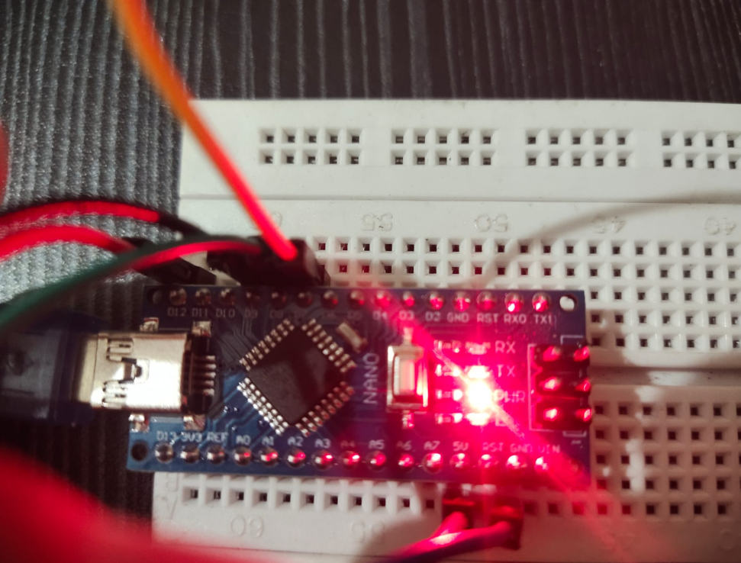

Light Emitting Diodes (LEDs)
LEDs are used as visual indicators to represent the authentication result. A green LED indicates successful authentication, while a red LED indicates failure. These indicators provide immediate visual feedback to the user.
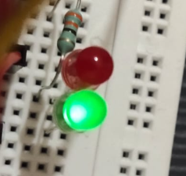

Buzzer
The buzzer is used to generate audio signals for system alerts. It produces different sound patterns based on the authentication result, thereby enhancing user awareness and system response.
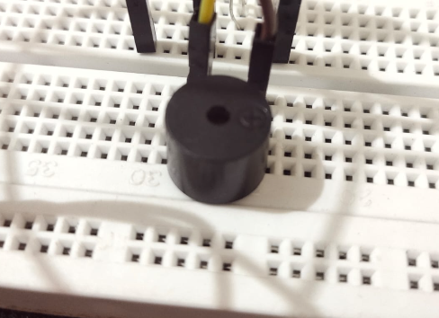

Servo Motor
The servo motor is used to simulate a door-lock mechanism. Upon successful authentication, the motor rotates to represent the opening of a gate or door. This demonstrates the practical application of the system in real-world scenarios.
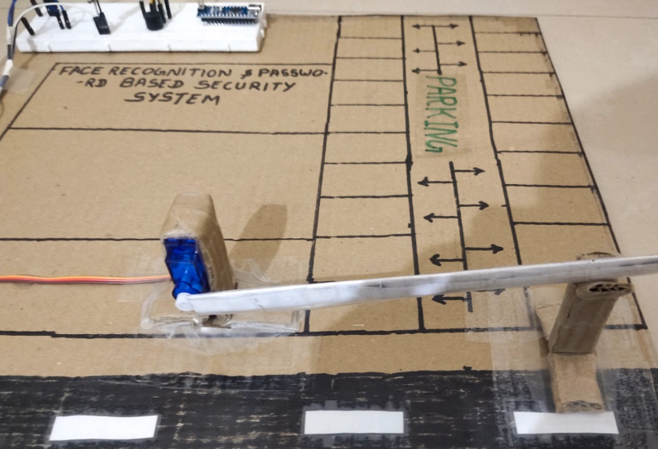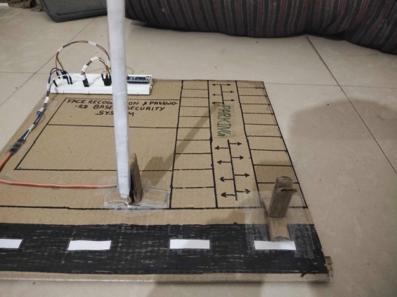
( CLOSE Position ) (OPEN Position )

Camera (Webcam)
A webcam is used to capture real-time images of the user for face recognition. It acts as the input device for the biometric authentication process and plays a critical role in the system’s functionality.

Integration of Technologies
The system integrates both software and hardware components to achieve a complete authentication solution. The Python application performs password verification and face recognition. Based on the result, signals are transmitted to the Arduino Nano using serial communication. The Arduino then controls the connected hardware components, such as LEDs, buzzer, and servo motor, to provide a physical response.
Software Details :

📂 Main Directory: parking_project
This directory contains all the necessary files and folders required for the implementation of the smart parking system, including face recognition, user management, hardware integration, and logging.

📁 Folder Details:

1. dataset/
- This folder stores the captured images of users for training the face recognition model.
- Images are collected during user registration.
- Used for training the face recognition algorithm.
👉 Purpose: Face data collection

File Details:

3. main.py
- The main application file of the project.
- Handles:
  - Face recognition
  - Password authentication
  - Parking slot logic
  - UI (Streamlit)
  - Arduino communication
👉 Purpose: Core system logic
Code :
import streamlit as st
import cv2
import os
import json
import numpy as np
import serial
import time
from datetime import datetime

# -------------------------
# App Config
# -------------------------
st.set_page_config(page_title="Face + Password Auth", layout="centered")

# -------------------------
# Helpers
# -------------------------
def open_camera():
cap = cv2.VideoCapture(0, cv2.CAP_DSHOW)
cap.set(cv2.CAP_PROP_BUFFERSIZE, 1)
cap.set(cv2.CAP_PROP_FRAME_WIDTH, 640)
cap.set(cv2.CAP_PROP_FRAME_HEIGHT, 480)
cap.set(cv2.CAP_PROP_FPS, 15)
cap.set(cv2.CAP_PROP_FOURCC, cv2.VideoWriter_fourcc(*"MJPG"))
return cap

def send_signal(signal):
try:
arduino = serial.Serial('COM3', 9600, timeout=1)
time.sleep(0.2)
arduino.write(signal.encode())
arduino.close()
except:
st.warning("⚠️ Arduino not connected")

def save_users():
with open("users.json", "w") as f:
json.dump(users, f, indent=4)

def save_logs():
with open("logs.json", "w") as f:
json.dump(logs, f, indent=4)

def add_log(username, status):
logs.append({
"user": username,
"status": status,
"time": datetime.now().strftime("%Y-%m-%d %H:%M:%S")
})
save_logs()

# -------------------------
# Load Data
# -------------------------
if os.path.exists("users.json"):
try:
with open("users.json", "r") as f:
users = json.load(f)
except:
users = {}
else:
users = {}

if os.path.exists("logs.json"):
try:
with open("logs.json", "r") as f:
logs = json.load(f)
except:
logs = []
else:
logs = []

# -------------------------
# Face Detectors
# -------------------------
face_detector = cv2.CascadeClassifier(cv2.data.haarcascades + "haarcascade_frontalface_default.xml")
profile_detector = cv2.CascadeClassifier(cv2.data.haarcascades + "haarcascade_profileface.xml")

# -------------------------
# Train Model
# -------------------------
def train_model():
if not os.path.exists("dataset"):
return False

recognizer = cv2.face.LBPHFaceRecognizer_create()
faces, ids = [], []

usernames = list(users.keys())

for file in os.listdir("dataset"):
path = os.path.join("dataset", file)
try:
img = cv2.imread(path, 0)
if img is None:
continue
username = file.split(".")[0]
if username in usernames:
idx = usernames.index(username)
faces.append(img)
ids.append(idx)
except:
continue

if len(faces) == 0:
return False

recognizer.train(faces, np.array(ids))
recognizer.save("trainer.yml")
return True

# -------------------------
# Face Login
# -------------------------
def face_login_streamlit(username):
if not os.path.exists("trainer.yml"):
st.error("⚠️ No trained model found. Please register first.")
return None, "NoModel"

recognizer = cv2.face.LBPHFaceRecognizer_create()
recognizer.read("trainer.yml")

cap = open_camera()
if not cap.isOpened():
st.error("Camera not accessible")
return None, "CameraError"

for _ in range(5):
cap.read()

FRAME_WINDOW = st.image([])
confidence_threshold = 60
consecutive_matches = 0
result_user = None

st.info("📸 Looking for face match... Stay in frame!")

for _ in range(120):
ret, frame = cap.read()
if not ret:
break

gray = cv2.cvtColor(frame, cv2.COLOR_BGR2GRAY)
faces = face_detector.detectMultiScale(gray, 1.2, 4, minSize=(60, 60))
if len(faces) == 0:
faces = profile_detector.detectMultiScale(gray, 1.2, 4, minSize=(60, 60))

label = "No face"
color = (0, 165, 255)

for (x, y, w, h) in faces:
roi = gray[y:y+h, x:x+w]
if roi.size == 0:
continue

roi = cv2.resize(roi, (200, 200))
predicted_id, conf = recognizer.predict(roi)

usernames = list(users.keys())
predicted_user = usernames[predicted_id] if predicted_id < len(usernames) else "Unknown"

if conf < confidence_threshold and predicted_user == username:
consecutive_matches += 1
label = f"✅ MATCH: {predicted_user} ({int(conf)})"
color = (0, 255, 0)
if consecutive_matches >= 3:
result_user = username
else:
consecutive_matches = 0
label = f"❌ {predicted_user} ({int(conf)})" if conf < confidence_threshold else f"Unknown ({int(conf)})"
color = (0, 0, 255) if conf < confidence_threshold else (0, 165, 255)

cv2.rectangle(frame, (x, y), (x+w, y+h), color, 2)
cv2.putText(frame, label, (x, max(25, y-10)),
cv2.FONT_HERSHEY_SIMPLEX, 0.6, color, 2)
break

FRAME_WINDOW.image(frame, channels="BGR")

if result_user:
break

time.sleep(0.01)

cap.release()
return result_user, "Authorized" if result_user else "FaceMismatch"

# -------------------------
# UI
# -------------------------
st.title("Face Recognition & Password Authentication System")

menu = ["Login", "Register", "Logs"]
choice = st.sidebar.selectbox("Menu", menu)

# -------------------------
# Register
# -------------------------
if choice == "Register":
st.subheader("👤 Register New User")

username = st.text_input("Username")
password = st.text_input("Password", type="password")

if st.button("Register"):
if username in users:
st.error("❌ User already exists!")
elif username == "" or password == "":
st.warning("⚠️ Please fill all fields")
else:
os.makedirs("dataset", exist_ok=True)
cam = open_camera()

if not cam.isOpened():
st.error("Camera not accessible!")
else:
for _ in range(5):
cam.read()

count = 0
FRAME_WINDOW = st.image([])
progress = st.progress(0)
st.info("📸 Capturing 25 face samples... Keep face centered!")

while count < 25:
ret, img = cam.read()
if not ret:
break

gray = cv2.cvtColor(img, cv2.COLOR_BGR2GRAY)
faces = face_detector.detectMultiScale(gray, 1.2, 4, minSize=(80, 80))

for (x, y, w, h) in faces:
face_roi = gray[y:y+h, x:x+w]
if face_roi.size == 0:
continue

face_roi = cv2.resize(face_roi, (200, 200))
cv2.imwrite(f"dataset/{username}.{count+1}.jpg", face_roi)

count += 1
cv2.rectangle(img, (x, y), (x+w, y+h), (0, 255, 0), 2)
cv2.putText(img, f"Captured: {count}/25", (10, 30),
cv2.FONT_HERSHEY_SIMPLEX, 1, (0, 255, 0), 2)
break

FRAME_WINDOW.image(img, channels="BGR")
progress.progress(count / 25)
time.sleep(0.03)

cam.release()

users[username] = {"password": password}
save_users()

if train_model():
st.success("✅ Registered & Trained Successfully!")
else:
st.error("❌ Training failed. Check dataset.")

# -------------------------
# Login
# -------------------------
elif choice == "Login":
st.subheader("🔐 Dual Authentication (Password → Face)")

username = st.text_input("Username")
password = st.text_input("Password", type="password")

col1, col2 = st.columns(2)

with col1:
if st.button("OPEN GATE (Password + Face)"):
if username in users and users[username]["password"] == password:
st.success("✅ Password Verified!")
st.info("🎥 Now verifying face...")

with st.spinner("Scanning face..."):
user, status = face_login_streamlit(username)

if user:
st.success(f"🎉 Fully Authorized: {user} ✅")
send_signal('1')
add_log(user, "Authorized (Password+Face)")
else:
st.error("❌ Face mismatch!")
send_signal('0')
add_log(username, "Face Mismatch")
else:
st.error("❌ Wrong credentials!")
send_signal('0')
add_log(username, "Wrong Password")

# with col2:
# if st.button("📱 Emergency Password Only"):
# if username in users and users[username]["password"] == password:
# st.success("✅ Emergency Access Granted!")
# send_signal('1')
# add_log(username, "Emergency Password")
# else:
# st.error("❌ Wrong credentials!")

# -------------------------
# Logs
# -------------------------
elif choice == "Logs":
st.subheader("📋 Access Logs")

if logs:
for log in logs[-20:][::-1]:
status_emoji = "✅" if "Authorized" in log["status"] else "❌"
st.write(f"👤 {log['user']} | {status_emoji} {log['status']} | ⏰ {log['time']}")
else:
st.info("📭 No logs yet")

4. trainer.yml
- Stores the trained model (LBPH Face Recognizer).
- Generated after training using dataset images.
👉 Purpose: Face recognition model file
Code :
%YAML:1.0
---
opencv_lbphfaces:
threshold: 1.7976931348623157e+308
radius: 1
neighbors: 8
grid_x: 8
grid_y: 8
histograms:
- !!opencv-matrix
rows: 1
cols: 16384
dt: f
data: [ ]

5. users.json
- Stores registered user details:
  - Username
  - Password
  - Face ID reference
👉 Purpose: User authentication data
Code :
{
"Deepak": {
"password": "12345"
},
"Anjana": {
"password": "123"
}
}

6. parking.json
- Maintains parking slot information:
  - Slot availability
  - Occupied/free status
👉 Purpose: Parking management system

7. logs.json
- Stores system logs such as:
  - Entry time
  - Exit time
  - User activity
👉 Purpose: Activity tracking & record keeping

8. requirements.txt
- Contains all required Python libraries:
  - OpenCV
  - NumPy
  - Streamlit
  - etc.
👉 Purpose: Dependency management
Code :
streamlit==1.38.0
opencv-python==4.10.0.84
numpy==1.26.4
bcrypt==4.2.0
pyserial==3.5
pillow==10.4.0
python-dateutil==2.9.0.post0

10. Arduino.cpp
- Contains Arduino code for:
  - LED control (Red/Green)
  - Buzzer
  - Servo motor (gate control)
👉 Purpose: Hardware integration
Code :
#include <Servo.h>
#include <LiquidCrystal.h>
#include <Keypad.h>

// LCD
LiquidCrystal lcd(7, 6, 5, 4, 3, 2);

// Servo
Servo myServo;

// Pins
int ledPin = 10;
int buzzerPin = 11;

// Keypad
const byte ROWS = 4;
const byte COLS = 4;

char keys[ROWS][COLS] = {
{'1','2','3','A'},
{'4','5','6','B'},
{'7','8','9','C'},
{'*','0','#','D'}
};

byte rowPins[ROWS] = {12, 13, A0, A1};
byte colPins[COLS] = {A2, A3, A4, A5};

Keypad keypad = Keypad(makeKeymap(keys), rowPins, colPins, ROWS, COLS);

// Variables
String enteredPassword = "";
bool passwordEntered = false;

void setup() {
Serial.begin(9600);

lcd.begin(16, 2);
lcd.print("Enter Password:");

myServo.attach(9);
myServo.write(0);

pinMode(ledPin, OUTPUT);
pinMode(buzzerPin, OUTPUT);
}

void loop() {

// 🔐 Password Input
char key = keypad.getKey();

if (key) {
if (key == '#') {
Serial.println(enteredPassword); // Send to Python
lcd.clear();
lcd.print("Checking...");
enteredPassword = "";
}
else if (key == '*') {
enteredPassword = "";
lcd.setCursor(0,1);
lcd.print(" ");
}
else {
enteredPassword += key;
lcd.setCursor(0,1);
lcd.print(enteredPassword);
}
}

// 🤖 Python Commands
if (Serial.available()) {
char data = Serial.read();

if (data == 'F') {
lcd.clear();
lcd.print("Show Face...");
}

else if (data == '1') {
accessGranted();
}

else if (data == '0') {
accessDenied();
}
}
}

void accessGranted() {
lcd.clear();
lcd.print("Access Granted");

digitalWrite(ledPin, HIGH);
tone(buzzerPin, 1000);

myServo.write(90);
delay(3000);

noTone(buzzerPin);
digitalWrite(ledPin, LOW);

myServo.write(0);

lcd.clear();
lcd.print("Enter Password:");
}

void accessDenied() {
lcd.clear();
lcd.print("Access Denied");

for(int i=0;i<3;i++) {
digitalWrite(ledPin, HIGH);
tone(buzzerPin, 500);
delay(300);
digitalWrite(ledPin, LOW);
noTone(buzzerPin);
delay(300);
}

lcd.clear();
lcd.print("Enter Password:");
}

Summary
The combination of these technologies enables the system to deliver secure, accurate, and real-time authentication. The integration of biometric verification with embedded hardware control enhances both the functionality and practical applicability of the system
More Code Informaition :

IMPLEMENTATION :
The implementation of the proposed system involves the integration of software-based authentication techniques with hardware-based control mechanisms. The system is designed in a modular manner, where each module performs a specific function and collectively contributes to the overall working of the system.
The implementation process can be divided into the following major modules:

1. User Interface Module
The user interface is developed using Streamlit, which provides an interactive platform for user interaction. It allows the user to enter login credentials such as username and password. The interface also displays system messages such as authentication status and instructions for face verification.
The interface is designed to be simple, responsive, and user-friendly, ensuring ease of operation even for non-technical users.

2. Authentication Module (Password Verification)
This module is responsible for verifying user credentials. When the user enters a username and password, the system compares the input values with the stored data in the database.
If the entered credentials match the stored records, the system allows the user to proceed to the next stage. Otherwise, access is denied immediately. This module acts as the first layer of security.

3. Face Detection and Recognition Module
After successful password verification, the system activates the camera to capture real-time video input. The face detection process is performed using OpenCV, which identifies the presence and location of a human face in the captured frame.
Once a face is detected, the system extracts facial features and converts them into a numerical representation known as face encoding. This encoding is then compared with the stored encoding of the registered user using the face recognition library.
If the similarity between the captured face and stored data meets the required threshold, the user is considered authenticated. Otherwise, the system rejects the authentication attempt.

4. Database Module
The database module stores all necessary user information, including usernames, passwords, and corresponding facial data. It plays a crucial role in retrieving user records during authentication.
The system ensures that data is accessed efficiently during runtime, enabling fast and reliable verification.

5. Serial Communication Module
After completing the authentication process, the system communicates the result to the hardware layer using serial communication. This is implemented using the PySerial library in Python.
The system sends specific signals to the Arduino Nano:
- A signal value representing successful authentication
- A signal value representing failed authentication
This module acts as a bridge between the software and hardware components.

6. Hardware Control Module (Arduino Nano)
The Arduino Nano receives the signal sent by the Python application and performs corresponding actions based on the received data.
- If authentication is successful, the Arduino activates the green LED, generates a short buzzer sound, and rotates the servo motor to simulate door opening.
- If authentication fails, the Arduino activates the red LED and triggers a buzzer alert without moving the servo motor.
This module enables real-time physical response based on system decisions.

7. Overall System Workflow
The complete working of the system can be summarized as follows:
- The user enters login credentials through the user interface.
- The authentication module verifies the username and password.
- If valid, the camera is activated for face recognition.
- The system detects and matches the face with stored data.
- Based on the result, a signal is sent to the Arduino Nano.
- The Arduino controls hardware components such as LED, buzzer, and servo motor.
- The system displays the final result to the user.

Implementation Outcome
The implemented system successfully demonstrates a dual-layer authentication mechanism that combines software-based verification with hardware-based response. It provides secure access control and simulates real-world applications such as smart door locking systems.

RESULTS AND DISCUSSION :
The developed system was tested under various conditions to evaluate its performance, accuracy, and reliability. The objective of testing was to verify whether the system could successfully authenticate users using both password verification and face recognition, along with providing appropriate hardware responses.
During the testing phase, multiple attempts were made using both correct and incorrect credentials. It was observed that the system accurately verified user credentials in the initial stage. When valid username and password combinations were entered, the system proceeded to the face recognition phase without delay. In cases of incorrect credentials, access was immediately denied, thereby preventing unauthorized attempts at an early stage.
The face recognition module was evaluated using real-time camera input. Under normal lighting conditions, the system demonstrated a high level of accuracy in detecting and recognizing faces. The captured facial image was successfully matched with the stored data in most cases, resulting in correct authentication. The response time of the system was also found to be satisfactory, with minimal delay between face detection and recognition.
The integration of hardware components further enhanced the effectiveness of the system. Upon successful authentication, the Arduino Nano received the signal from the Python application and executed the corresponding actions. The green LED was activated, the buzzer produced a short confirmation sound, and the servo motor rotated to simulate the opening of a door. This demonstrated the practical applicability of the system in real-world scenarios such as smart access control.
In contrast, when authentication failed due to incorrect password or unmatched facial data, the system responded appropriately by denying access. The red LED was activated, and the buzzer generated an alert signal. The servo motor remained in its initial position, indicating that access was not granted. This clear distinction between successful and failed attempts improved user understanding and system transparency.
However, certain limitations were observed during testing. The performance of the face recognition module was affected under poor lighting conditions or when the user’s face was partially covered. In such cases, the system sometimes failed to detect or correctly recognize the face. Additionally, variations in facial appearance, such as wearing glasses or changes in facial expressions, slightly influenced the accuracy.
Despite these limitations, the overall performance of the system was found to be reliable and efficient. The combination of password authentication and face recognition significantly improved security compared to single-layer authentication systems. The hardware integration provided an additional advantage by enabling real-time physical response, making the system more practical and interactive.
In conclusion, the results indicate that the proposed system is capable of providing secure, accurate, and efficient authentication. The dual-layer approach effectively reduces the risk of unauthorized access, while the hardware implementation demonstrates its potential for real-world applications.
APPLICATIONS :

The proposed system, which integrates password-based authentication with face recognition and hardware control, has wide applicability in various real-world domains. Its ability to provide secure, reliable, and real-time access control makes it suitable for both personal and industrial use.

1. Smart Door Lock Systems
The system can be effectively used in smart home security systems. By integrating the servo motor as a door-lock mechanism, access to a house or room can be controlled through dual authentication. Only authorized users can unlock the door, ensuring enhanced safety.

2. Attendance Management Systems
This system can be applied in educational institutions and workplaces for automated attendance marking. Face recognition ensures accurate identification of individuals, while password verification adds an extra layer of security, reducing proxy attendance.

3. Banking and Financial Security
In banking applications, where security is of utmost importance, the system can be used for secure login and transaction authorization. The dual authentication mechanism significantly reduces the risk of unauthorized access and fraud.

4. Secure Access to Restricted Areas
The system can be deployed in high-security zones such as laboratories, data centers, and research facilities. It ensures that only authorized personnel are granted access, thereby protecting sensitive information and infrastructure.

5. Parking and Vehicle Access Systems
The project can be extended to smart parking systems where entry is controlled using face recognition and authentication. The servo motor can act as an automatic gate controller, opening only for authorized users.

6. Office Automation Systems
In corporate environments, the system can be used to control access to offices, cabins, or confidential areas. It enhances organizational security and maintains proper access control.

7. Personal Device Security
The system can be adapted for securing personal devices such as computers and laptops. It ensures that only the authorized user can access the system, even if the password is known to others.

8. Industrial and IoT Applications
With further development, the system can be integrated into IoT-based security systems. It can be used in industries for monitoring and controlling access to machinery or sensitive operations.

ADVANTAGES :
The proposed system offers several significant advantages over traditional authentication methods. By combining password-based verification with face recognition and hardware integration, the system provides a more secure, reliable, and practical solution for modern access control requirements.

Enhanced Security
The system uses a dual-layer authentication mechanism, which significantly improves security. Even if the password is compromised, unauthorized users cannot gain access without passing the face recognition stage. This reduces the risk of security breaches.

Accurate User Verification
Face recognition ensures that the identity of the user is verified based on unique facial features. This minimizes the chances of impersonation and ensures that access is granted only to the rightful user.

Real-Time Authentication
The system performs authentication in real time. Both password verification and face recognition are processed quickly, providing a smooth and efficient user experience without noticeable delay.

Hardware-Based Response
Unlike purely software-based systems, this project includes hardware integration. Devices such as LEDs, buzzer, and servo motor provide immediate visual and physical feedback, making the system more interactive and practical for real-world applications.

User-Friendly Interface
The system is designed with a simple and intuitive user interface. Users can easily interact with the system without requiring technical knowledge, which enhances usability.

Cost-Effective Implementation
The system is developed using open-source software tools and low-cost hardware components such as Arduino Nano, LEDs, and servo motors. This makes it affordable and accessible for a wide range of applications.

Scalability and Flexibility
The modular design of the system allows it to be easily expanded. Additional features such as multi-user support, cloud integration, or mobile control can be implemented without major changes to the existing structure.

Reduced Dependency on Single Authentication Method
By combining two different authentication techniques, the system overcomes the limitations of individual methods. This ensures a more balanced and reliable approach to security.

LIMITATIONS :
Although the face recognition-based security system provides an efficient and automated approach for authentication, it still has certain limitations that affect its overall performance and reliability.

1. Lighting Conditions
The system’s accuracy can be significantly affected by poor or uneven lighting. In low light or overly bright environments, face detection may fail or produce incorrect recognition results.

2. Camera Quality Dependency
The performance of the system heavily depends on the quality of the camera used. Low-resolution cameras may not capture facial features clearly, leading to reduced accuracy.

3. Angle and Pose Variation
The model works best when the user’s face is directly facing the camera. Extreme angles, side poses, or partially visible faces can reduce recognition accuracy.

4. Limited Dataset Training
If the system is trained with a limited number of images per user, it may struggle to correctly identify faces in real-time conditions, especially when facial expressions change.

5. Processing Delay
Depending on the hardware (especially in low-cost systems), real-time face recognition may introduce slight delays in authentication and hardware response (LED, buzzer, servo motor).

6. Hardware Dependency
The system relies on external hardware components like Arduino, servo motor, buzzer, and LEDs. Any malfunction or wiring issue can directly affect system performance.

7. Security Limitations
While face recognition adds a layer of security, it is not completely foolproof. There is still a possibility of spoofing using photos or videos if advanced anti-spoofing techniques are not implemented.

8. Environmental Factors
Dust, camera obstruction, or background noise (for buzzer-based alerts) may indirectly impact the system’s usability and efficiency.
FUTURE SCOPE :

The proposed Face Recognition-based Security System has strong potential for further enhancement and expansion. With advancements in Artificial Intelligence (AI), Internet of Things (IoT), and embedded systems, this project can be upgraded into a more intelligent, secure, and real-time automation system.

1. Integration with AI-based Deep Learning Models
In the future, advanced deep learning models such as CNN (Convolutional Neural Networks) can be implemented to improve accuracy, speed, and robustness against changes in lighting, expressions, and angles.

2. Cloud-Based Face Recognition System
The system can be extended to a cloud platform where facial data is stored and processed remotely. This will enable centralized monitoring, scalability, and real-time updates from anywhere.

3. Mobile Application Integration
A dedicated mobile application can be developed to allow users to monitor access logs, receive alerts, and control the system remotely using smartphones.

4. Multi-Factor Authentication System
To enhance security, the system can be combined with additional authentication methods such as OTP verification, fingerprint scanning, or password entry along with face recognition.

5. IoT-Based Smart Security System
By integrating IoT technology, the system can be connected to smart home devices, enabling automated door locking, surveillance alerts, and real-time notifications.

6. Anti-Spoofing Mechanism
Future improvements can include liveness detection techniques such as eye movement tracking, blinking detection, or 3D depth sensing to prevent spoofing using photos or videos.

7. Real-Time Database Integration
The system can be connected to real-time databases like Firebase or AWS, allowing instant updates of user entries, logs, and security events.

8. Industrial and Commercial Expansion
This system can be scaled for use in offices, banks, hostels, parking systems, and restricted zones where high-level security is required.

9. Smart Surveillance System
Integration with CCTV networks can transform it into a complete intelligent surveillance system capable of tracking and identifying individuals across multiple cameras.

CONCLUSION :

The Face Recognition-based Security System successfully demonstrates an efficient and automated approach for access control using image processing and embedded hardware integration. The system combines computer vision techniques with Arduino-based components such as LED indicators, buzzer alerts, and servo motor control to provide a complete security solution.
The developed model is capable of identifying authorized users in real-time and triggering appropriate actions, such as unlocking a door for recognized individuals and generating alerts for unauthorized access attempts. This enhances both security and convenience compared to traditional manual authentication methods.
Throughout the implementation, it was observed that the system performs effectively under normal conditions, with satisfactory accuracy and response time. The integration of hardware and software components ensures practical applicability in real-world environments such as homes, offices, and restricted areas.
However, like any system, it has certain limitations such as dependency on lighting conditions, camera quality, and computational resources. Despite these challenges, the system provides a strong foundation for further improvements using advanced AI, cloud computing, and IoT technologies.
In conclusion, this project proves that face recognition technology, when combined with embedded systems, can significantly improve modern security systems and pave the way for smarter and more intelligent access control solutions in the future.

